Experiment: 9
Aim:To design and implement a Theme Settings web page using HTML, CSS, and JavaScript that allows users to switch between Light and Dark themes, save the selected theme using local Storage, load the saved preference, and clear the stored theme settings.
Software/Tools Required: VSC, HTML, css, JavaScript
Output:
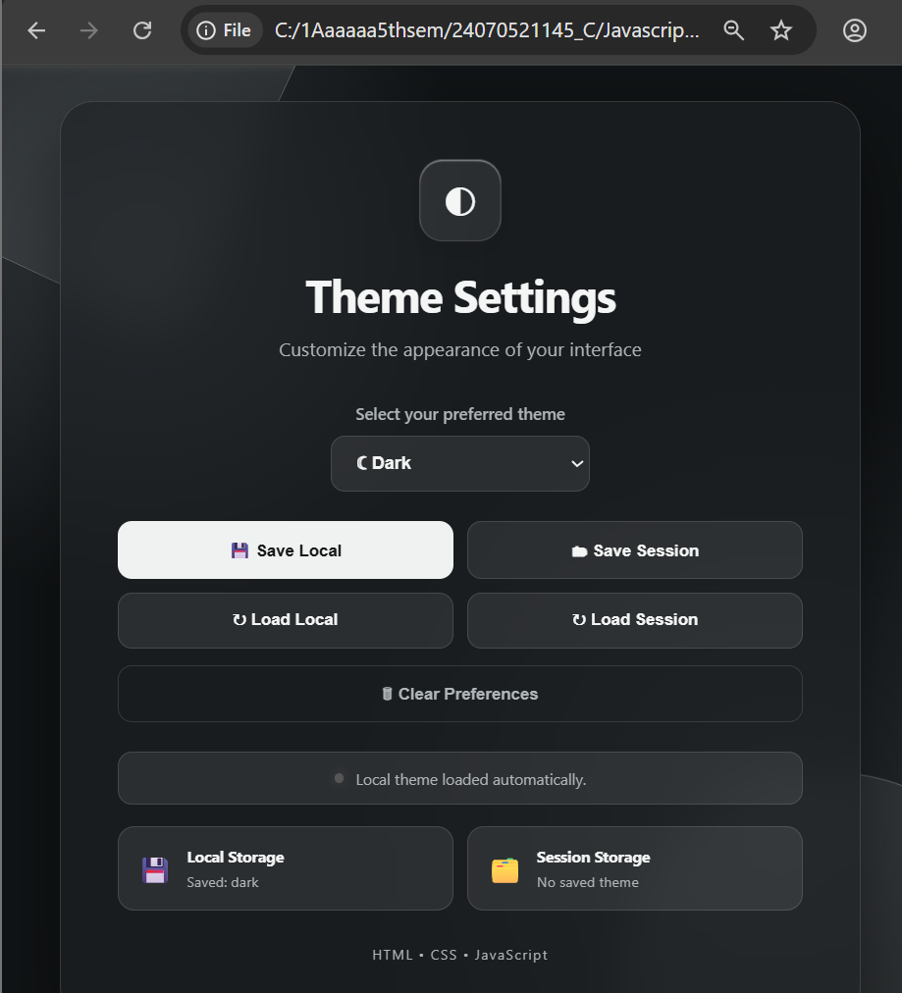
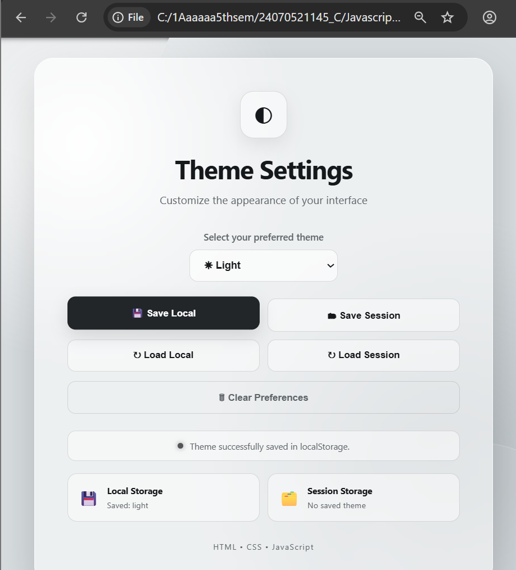
Result: The Theme Settings webpage was successfully implemented using HTML, CSS, and JavaScript. The user can switch between Light and Dark themes, save the selected theme in localStorage, load the saved preference, and clear the stored theme. The selected theme also remains available after refreshing the webpage, demonstrating successful client-side preference storage.

